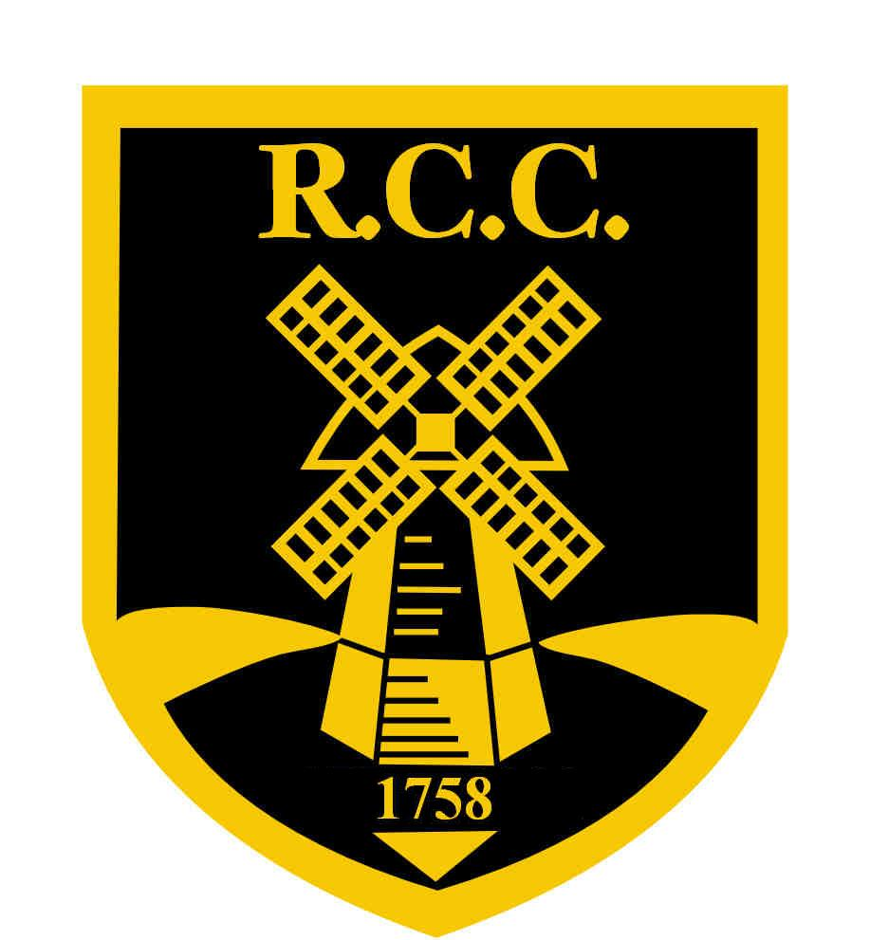

Rottingdean Cricket Club

First Aiders

Damon Crane
Chris McLachlan
Tara Norris
Jon Swinscoe
Raf Swinscoe
Dan Westcott

